**Women’s Counselling and Therapy Service**

**Trustees Recruitment**

**Candidate Information Pack 2024**

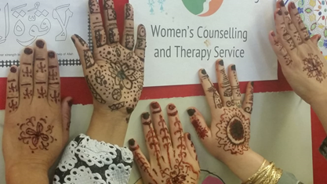

Visit our website - [www.womenstherapyleeds.org.uk](http://www.womenstherapyleeds.org.uk)

Contents

1. Introduction 3

Welcome from the Trustees 3

1.1 About the Service 4

1.2 The role of the Board of Trustees 4

1.3 About role of Trustee 5

1.4 Role Description 5

1.5 Person specification 6

1.6 Terms of appointment including time commitment 6

1.7 What WCTS offers in return 6

2. How to apply for the role of Trustee 7

3. Timetable 7

4. Reasonable adjustments 8

5. How to ask questions during the recruitment process 8

# Introduction

# Welcome from the Trustees

Thank you for your interest in the role of Trustee at Women’s Counselling and Therapy Service. Trustees play a critical part in this highly regarded, specialist charity. As we celebrate 40 years of services and move into the next stage of development we are seeking to strengthen the Board adding two or three new trustees to our current complement of eight.

We are looking for women with a passion for mental health or living in / working with communities experiencing deprivation. We are particularly interested in hearing from women with experience of managing events or with a legal or charity background, alongside those with experience in the counselling and therapy field especially of long term work as practitioners and or clients.

We especially invite young women to consider this opportunity (that is under 30 years old as this age group is currently under represented on the Board).

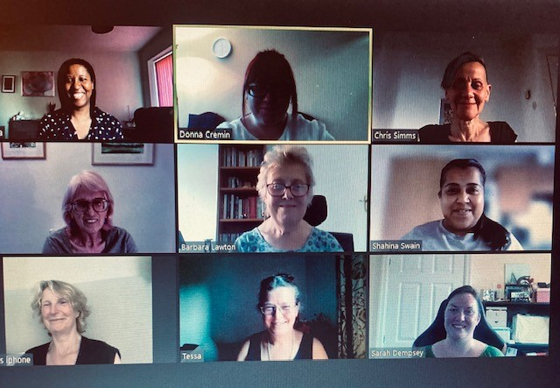

This is a critical time for beneficiaries as we understand more about the impacts of the pandemic in the context of exploding costs of living and increasing social challenges.

The organisation has grown five fold over the last 10 years, a journey of building on success as well as change. Trustees will be leading a review of strategy in 2023 shaping the organisation’s offer into Leeds and more widely for the next five years.

So, you will be joining us as we start to deliver the future direction and impact of the charity. We very much hope that you will be able to join the Board in this exciting journey.

Yours sincerely,

WCTS Board of Trustees

## 1.1 About the Service

WCTS has operated continuously since 1982, initially as an Industrial and Provident Society with charitable objectives, and then as a charitable company limited by guarantee from 2011. WCTS is governed by articles of association. The Board comprises between eight and twelve trustees.

Our charity objectives are to:

1. Provide advice and guidance, counselling and psychotherapeutic services including self-help support for women and girls of all ages
2. Advance the education of the public and of psychotherapists and mental health workers in particular, in the causes, effects, treatment and reduction of psychological/mental health problems in women and girls.

We operate mainly in the Leeds area, and particularly in areas suffering from economic deprivation working with women 16+ experiencing multiple disadvantage.

Our aims are to support marginalised and vulnerable women recover from the impacts of negative life experiences and improve their life chances by: reducing their levels of psychological distress/mental health problems; improving their levels of self-esteem and confidence; increasing their resilience; empowering them with skills for dealing with problems or tackling difficult situations, relationships and, for some, mothering.

We offer access to trauma specialised long-term ie up to two years, psychotherapeutic services that take account of both gender and wider power structures in society, and the potential impact of severe and/or long-term adversity on development, capacity to form and sustain healthy relationships and resilience.

You can read more about our 40 year history [here](https://www.womenstherapyleeds.org.uk/history/)

You can read our latest Impact Reports, Evaluations and Financial Accounts [here](https://www.womenstherapyleeds.org.uk/resources/)

## 1.2 The role of the Board of Trustees

The Board oversees and is accountable for the efficient running of WCTS, ensuring it is solvent, well run and of good reputation, safeguarding assets and applying them for the charitable purposes as detailed in our charitable objects.

WCTS Board is, however, much more than that: it is engaged in and supportive of the CEO, staff and the work, providing inspiration and constructive challenge. The Board and staff team work together to review progress and develop strategy.

WCTS is a charity registered in England and Wales and is a registered company. Note that when people become a trustee of the WCTS, they also become a director of a registered company with the responsibilities that come with this role. WCTS has insurance to cover our activities including Trustee Indemnity insurance.

## 1.3 About role of Trustee

We are seeking two or three new trustees to join the Board and work to ensure the charity’s ongoing success.

Essentially trustees need to:

* **Be eligible to be a charity trustee**

At least 16 years old. Not disqualified (ie being bankrupt, having an unspent conviction for certain offences, being on the sex offenders’ register)

* **Ensure the charity carries out purposes for the public benefit** These are our objectives set out in above.
* **Comply with your charity’s governing document and the law**
* **Act in your charity’s best interests**
* **Manage your charity’s resources responsibly** Acting responsibly, reasonably and honestly.
* **Act with reasonable care and skill**

As someone responsible for governing a charity, you should give enough time, thought and energy to your role, for example by preparing for, attending and actively participating in all trustees’ meetings

* **Ensure your charity is accountable** complying with statutory accounting and reporting requirements, complying with the law, being well run and effective

More information is available from the [Charity Commission's Essential Trustee guide](https://www.gov.uk/government/publications/the-essential-trustee-what-you-need-to-know-cc3/the-essential-trustee-what-you-need-to-know-what-you-need-to-do#s2)

## 1.4 Role Description

Providing leadership to the organisation through the Board ensuring that everyone remains focused on the delivery of the organisation’s strategic plan, charitable purposes to provide public benefit, and supporting the CEO and staff team by:

* Attending the Board of Trustee meetings (usually eleven meetings a year) plus a strategic away day.
* Activity contributing to discussions and bringing impartiality and objectivity to decision-making.
* Pre-reading and consideration of Board papers
* Participating in annual review of board structure, role, and effectiveness
* Activity participating in an annual individual meeting with the Chair to support your access to full contribution
* Providing support to the CEO on occasion with particular areas of work

We are seeking women who are keen to play active roles in the Board. Everyone experiences mental health challenges at times: everyone’s view on what WCTS offers into Leeds communities is valid and important.

## Person specification

We are particularly looking for new trustees with the following:

* Strong affinity with WCTS’ vision and mission
* Knowledge of the counselling and psychotherapy field
* Event Management or Legal or Charity Management experience
* Experience of counselling as a client (please note if you have accessed services at WCTS you will need to have ended at least three years ago)

## Terms of appointment including time commitment

The time commitment for the role of Trustee is expected to be five - six hours per month including:

* Reading and reflecting on Board papers
* Attending Board trustee meetings and AGM (the third Monday of the month at 6pm)
* Annual individual meeting with Chair around 1.5 hours.
* Annual Away Day with the trustees and staff

The term of office is initially for three years, from November 2022. Trustees can stand for re-election for further terms of three years.

## What WCTS offers in return

You will be joining an active, positive, skilled board: WCTS has strong commitment and contribution from its trustees, and staff work closely to support good governance. WCTS will offer full support to its new trustees in the form of induction, an existing trustee ‘buddy’ and other development, reflection and learning opportunities.

All trustee roles are unpaid; all out of pocket expenses will be reimbursed.

# How to apply for the role of Trustee

To apply, please complete the application form below and send to [tessadenham@womenstherapyleeds.org.uk](mailto:tessadenham@womenstherapyleeds.org.uk) **and include:**

[**Application Form**](https://www.womenstherapyleeds.org.uk/wp-content/uploads/WCTS-Trustee-Application-Form-2022-1.docx)

**Diversity and Inclusion**. We actively welcome applications from all women from diverse backgrounds, including and especially women of colour. In order to monitor our progress you are invited to complete and return [this monitoring form](https://www.womenstherapyleeds.org.uk/wp-content/uploads/WCTS-Equality-Monitoring-Form.docx) The form will not be treated as part of the application, it is treated as confidential and used only for statistical purposes.

We aim to create a culture that is open about the imbalance of power for many; one that respects and values diversity and difference promoting dignity and equality, and encouraging individuals to develop and maximise their true potential.

Please note that: The roles are subject to two satisfactory references and an enhanced Disclosure and Barring check. See a full timetable for the recruitment process below.

# Timetable

|  |  |
| --- | --- |
| Applications open | *04 July 2024* |
| You are welcome to contact us for an informal discussion before sending in an application. See section 5. below | *July and August* |
| Meet the trustees– you are invited to find out more about WCTS, meet some of the trustees and the CEO in this hour at our offices.  Book by emailing Tessa Denham  *Please note that this is not part of the application / selection process.* |  |
| Deadline for applications | *Open – rolling recruitment* |

Interviews will be in person, with two current trustees and will be supported by the CEO.

# Reasonable adjustments

We recognise and welcome our responsibility to remove any barriers in our recruitment and selection process for women with disabilities. We have made changes to do this, and if you have a disability and identify any further barriers in the job description or recruitment process, please tell us of these in your application, or contact us (see below). We are committed to making reasonable adjustments to the role wherever possible and it would help us to know your needs to do this. Any such enquiries will be treated as strictly confidential.

# How to ask questions during the recruitment process

If you have any queries about any aspect of the recruitment process, need additional information or wish to have an informal and confidential discussion then please contact Tessa Denham, Chief Executive Officer [tessadenham@womenstherapyleeds.org.uk](mailto:tessadenham@womenstherapyleeds.org.uk) or Freya Hirst, Operations/Deputy CEO [freyahirst@womenstherapyleeds.org.uk](mailto:freyahirst@womenstherapyleeds.org.uk)

Women’s Counselling and Therapy Service

43 Park Square North

Leeds

LS1 2NP

Registered Charity Number 1145377