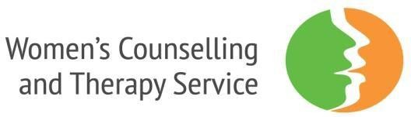

# INFORMATION AND GUIDANCE

Women’s Counselling and Therapy Service was established in 1982 to provide a counselling service run by women. The service provides individual and group counselling and psychotherapy to women living in Leeds, who are on a limited income and who have moderate to severe, often long-standing, mental health needs.

We are passionate about offering high quality thoughtful services to support women in their struggles with painful experiences and make any changes in their lives that are important to them.

**Specific Goals:**

We focus on the following goals:

* Providing a specialised, expert and accessible therapy service. We do this for women living with long-standing moderate to severe mental health difficulties.
* Addressing health inequalities. We focus on women from BME communities, women with low incomes living in deprived communities, lesbian women and women with disabilities.
* Contributing to meeting the needs of marginalised and vulnerable women. Specifically by broadening availability and improving accessibility.
* Organisational excellence. We prioritise maintaining and developing the quality of our therapy and counselling which results in sustainable positive outcomes for women.

The organisation operates to high professional standards and works to the ethical framework of BACP.

Further details about the organisation and our work can be found on our website at [www.womenstherapyleeds.org.uk](http://www.womenstherapyleeds.org.uk/)

# Your Application for Employment

* We only accept applications on the WCTS application form. Please do not include CVs.
* Please complete the application form in full.
* ***Please read the job description and use the person specification to assist you in completing your application. Include specific examples of how your skills, knowledge, experience and other attributes match the employee specification.***
* The application form may be completed electronically or hand written.
* If appropriate to the application, please indicate your preferred working hours/pattern.
* Please return your completed application form to:

|  |  |
| --- | --- |
| sophiaulhaq@womenstherapyleeds.org.uk or by post marked ‘Private & Confidential’ to: | |
| Sophia Ulhaq, 43 Park Square, Leeds LS1 2NP |  |

* We will acknowledge the receipt of electronic applications.
* If you have any questions please contact us on 0113 245 5275